__________________________________________________

**Emp Name : Radha Kadam**

**Emp Id : 46218925**

* **What is SonarQube?**

SonarQube is an open-source platform developed by SonarSource for continuous inspection of code quality to perform automatic reviews with static analysis of code to detect bugs, code smells on 29 programming languages.

* **Why SonarQube?**

SonarQube reduces the risk of software development within a very short amount of time. It detects bugs in the code automatically and alerts developers to fix them before rolling it out for production. SonarQube also highlights the complex areas of code that are less covered by unit tests.

* **SonarQube Architecture :**

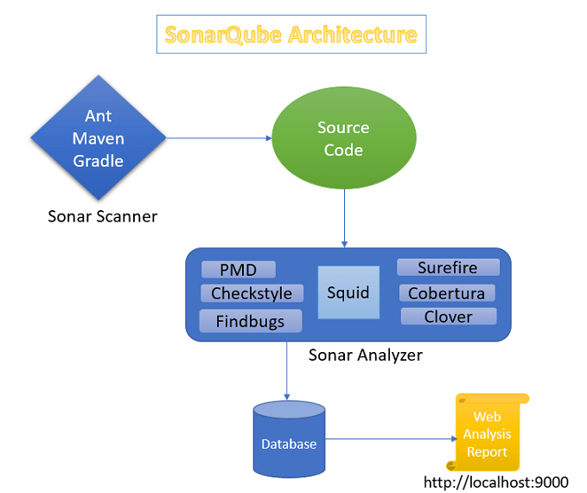

* **Sonar Scanner:**An analysis request is triggered using one of three possible methods:
  + - * + Maven Plugin
        + Ant Task
        + Java Runner
* **Source Code:**Source code which need to be analysed.
* **Sonar Analyzer:**  
  Sonar receives the request and starts analysing the source code of the project. The analysis is based on the Sonar profile of the project, activating any additional plugins or reporting capabilities, if any.
* **SonarQube Database:**When the analysis is finished, the results will be stored in the database for future reference and history tracking.
* **Reports:**Finally, the user interface (IDE: Eclipse/Web dashboard Reports) and its components are updated with the new data. You can access the data from your web browser and dashboard. Sonar reporting is also made available within your IDE, either Eclipse or IDEA, which allows you to review and correct code violations on the spot.
* **SonarQube Installation Steps:**

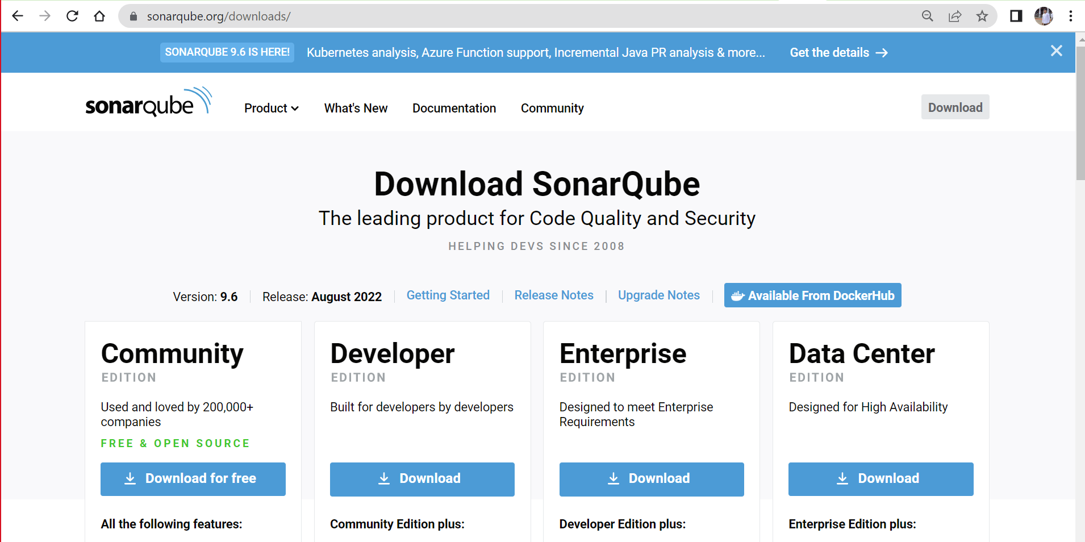

After downloading community…extract the zip file

Now open the cmd and then enter the cmd as below

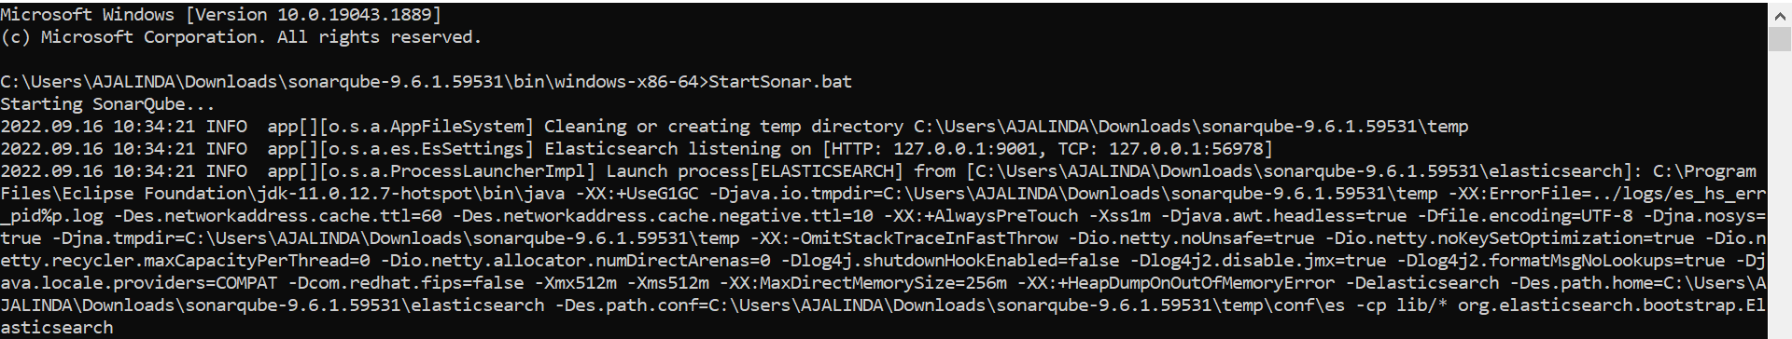

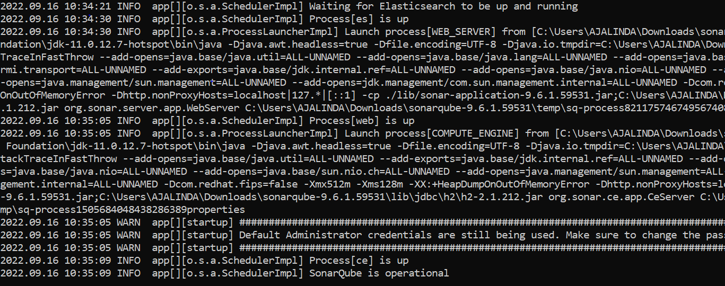

Open the localhost:9000 in chrome

Both credentials are admin,login to SonarQube

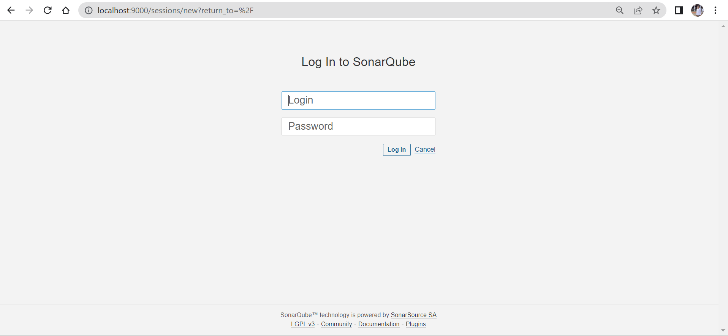

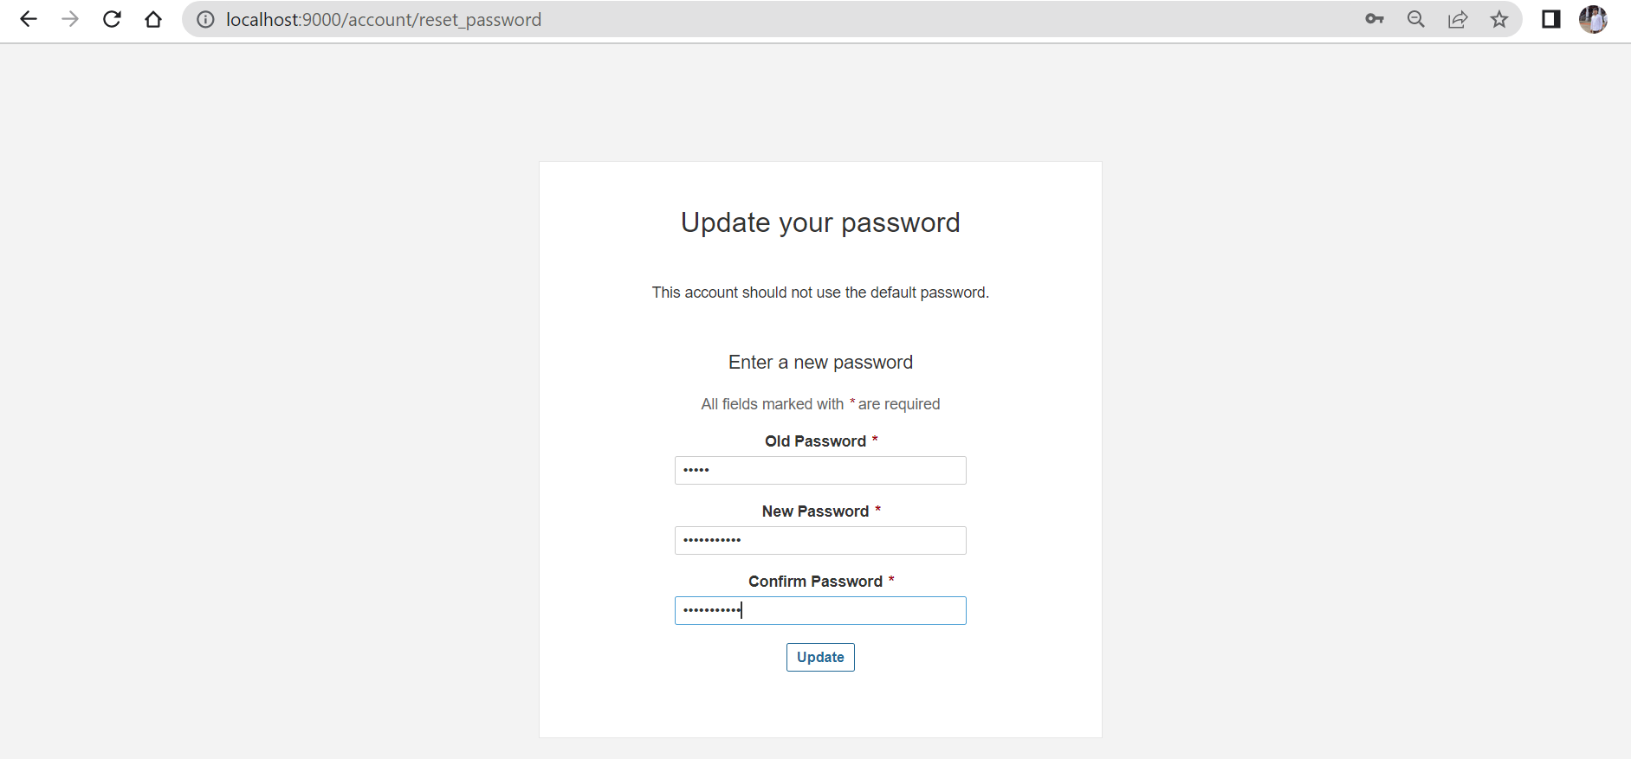

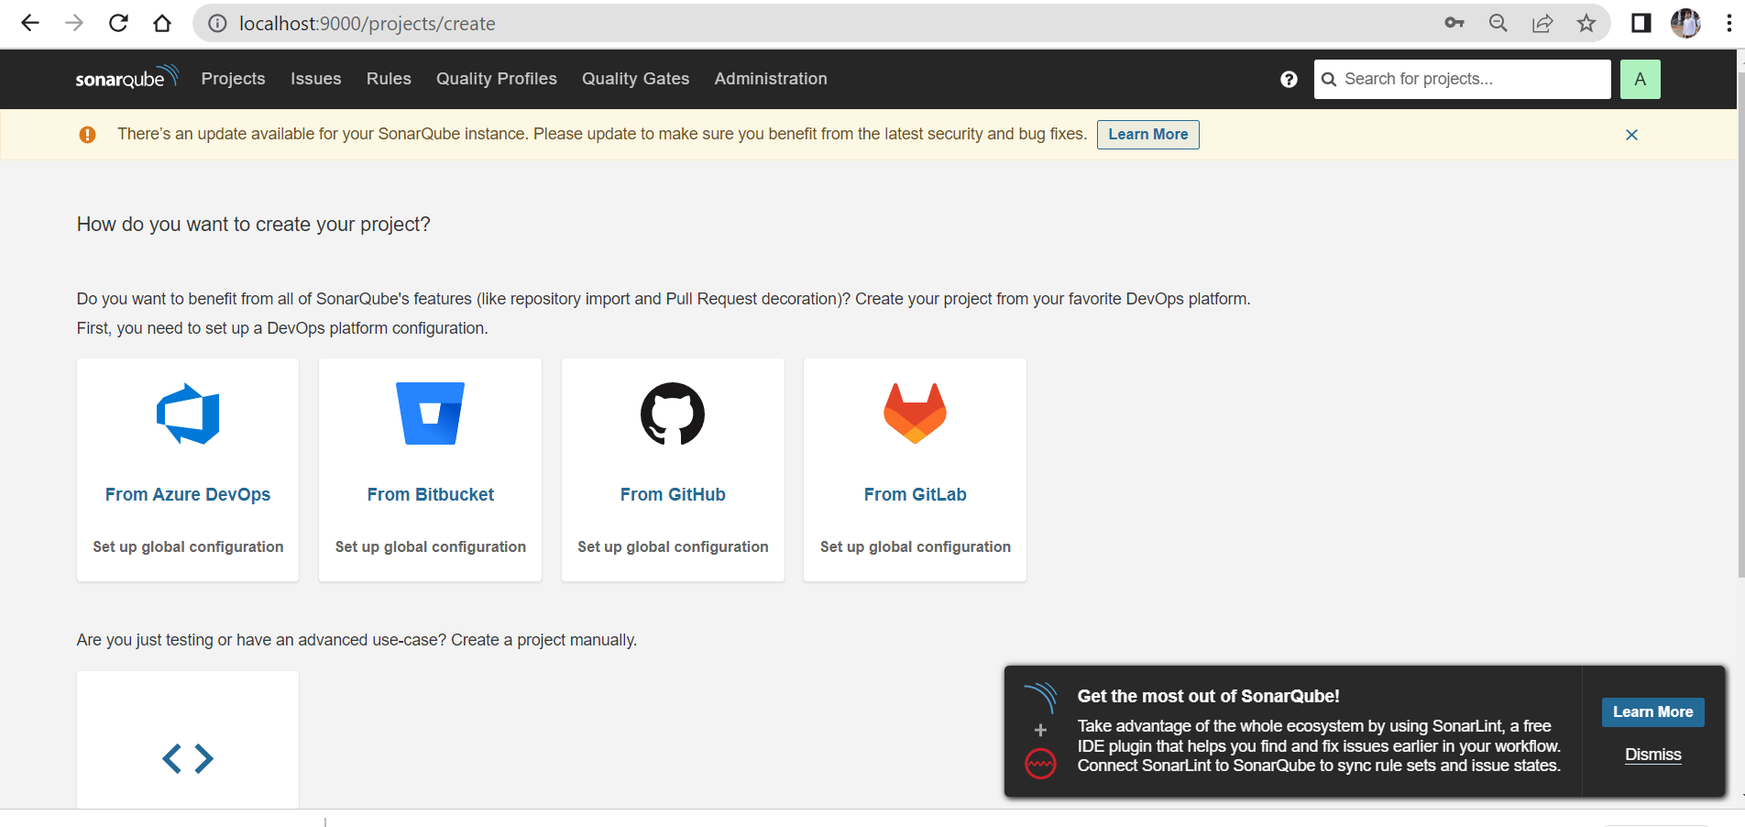

**Add this in text in pom.xml (under plugins)**

<plugin>  
                <groupId>org.sonarsource.scanner.maven</groupId>  
            <artifactId>sonar-maven-plugin</artifactId>  
            <version>3.8.0.2131</version>  
            </plugin>  
                  
            <plugin>  
            <groupId>org.jacoco</groupId>  
            <artifactId>jacoco-maven-plugin</artifactId>  
            <version>0.8.5</version>  
            <executions>  
              <execution>  
                  <id>prepare-agent</id>  
                  <goals>  
                   <goal>prepare-agent  
                   </goal>  
                 </goals>  
              </execution>  
              <execution>  
              <id>report</id>  
              <goals>  
              <goal>report</goal>  
              </goals>  
              </execution>  
            </executions>  
                        </plugin>

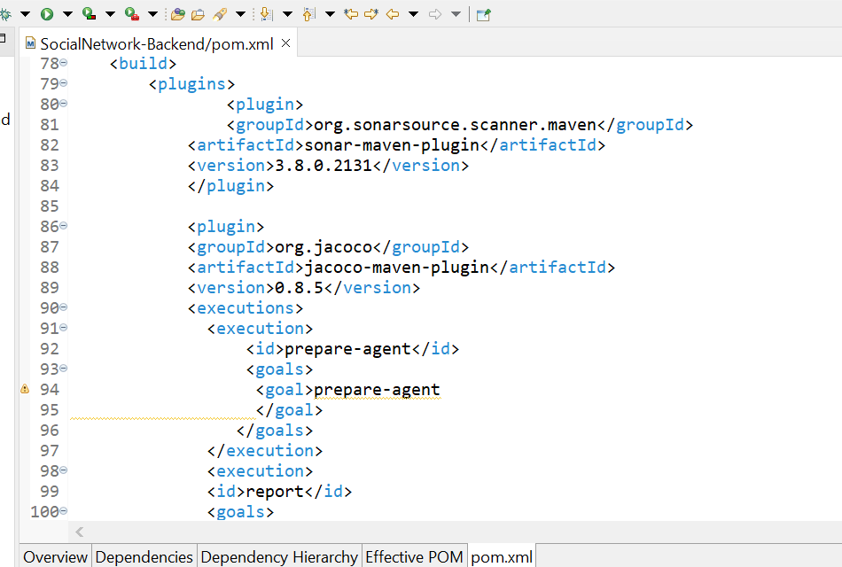

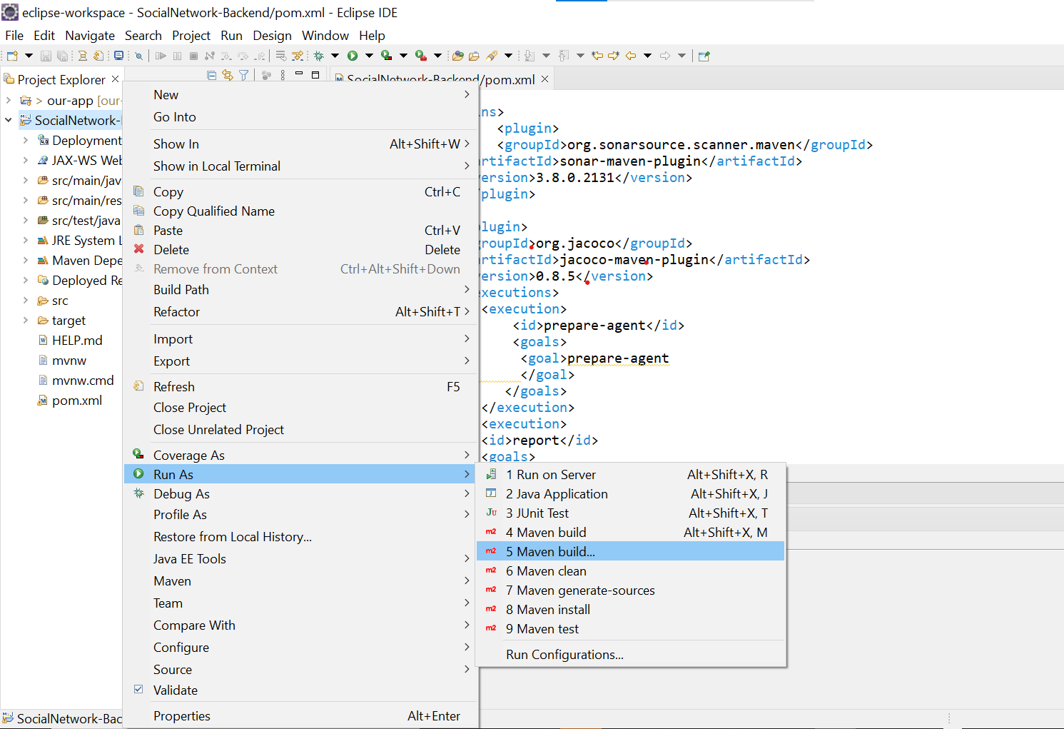

In goals text field paste the code as below ,apply and run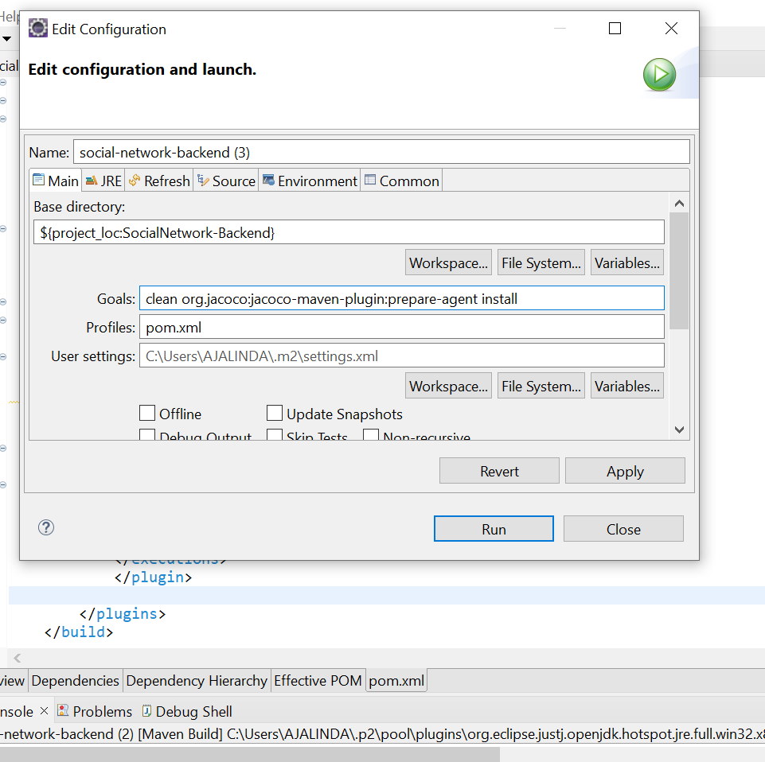

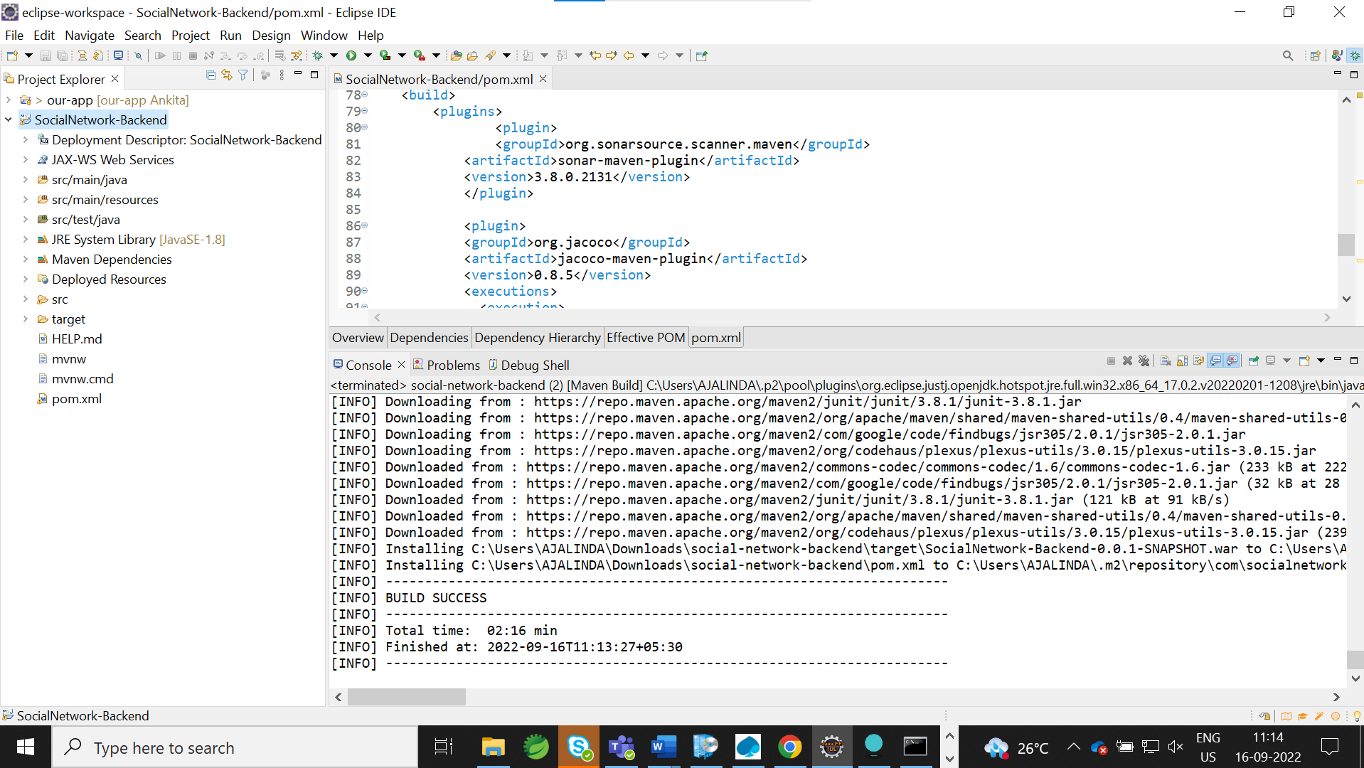

open sonar in chrome using localhost:9000

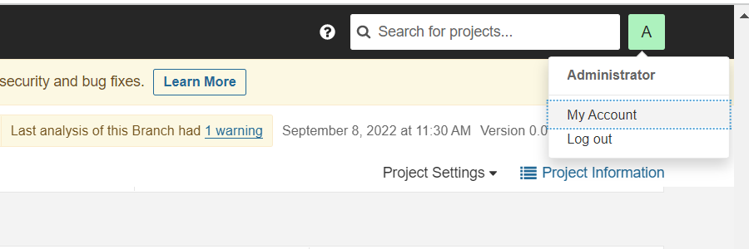

Open security and then generate token like below and copy the generated token use the token in eclipse

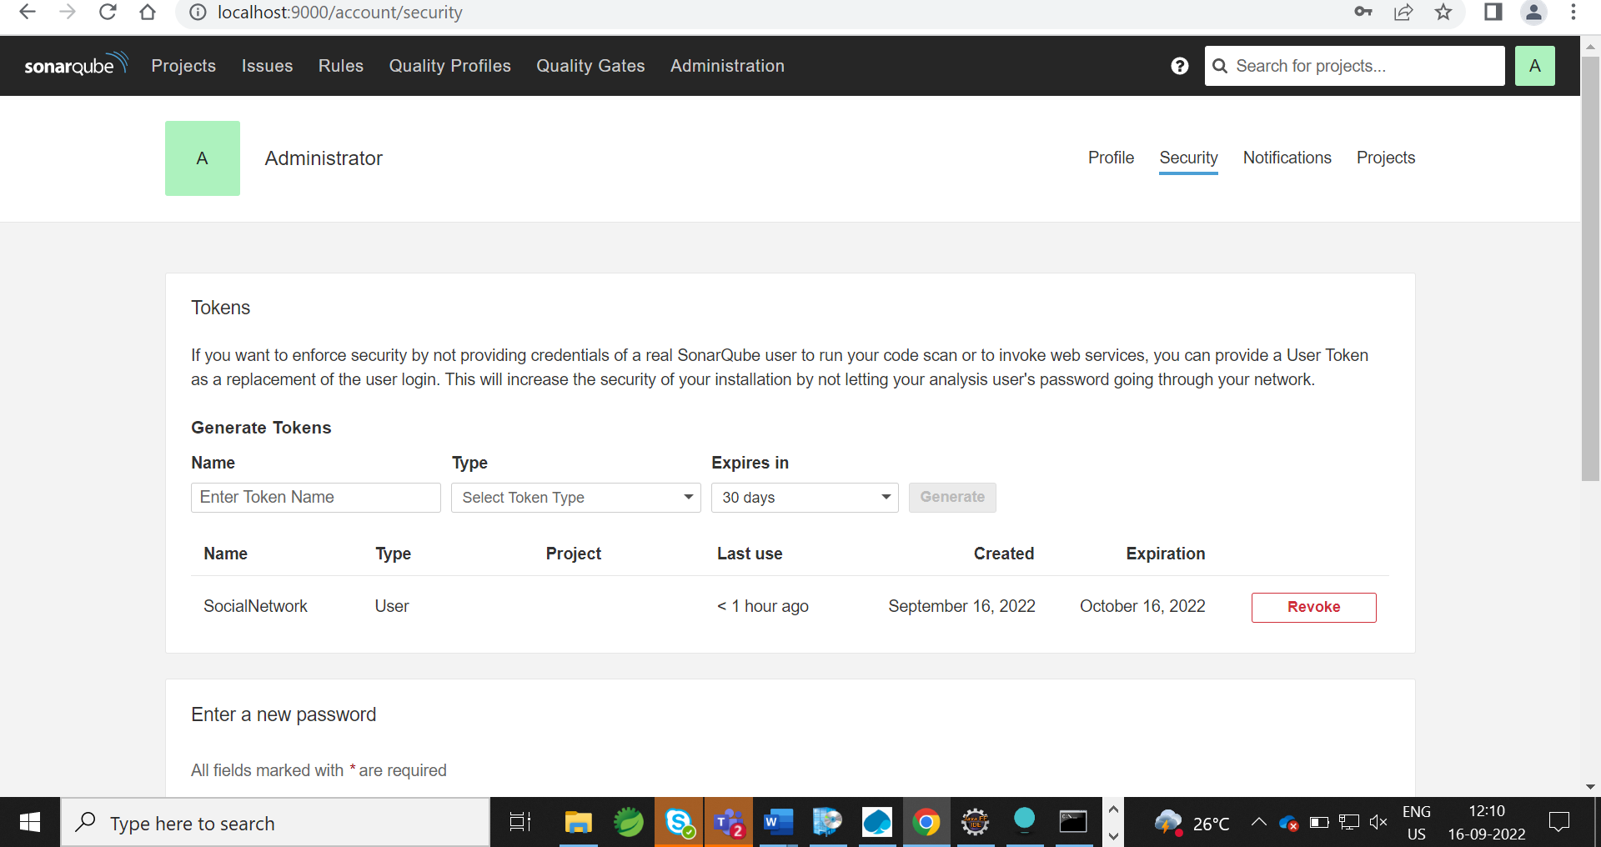

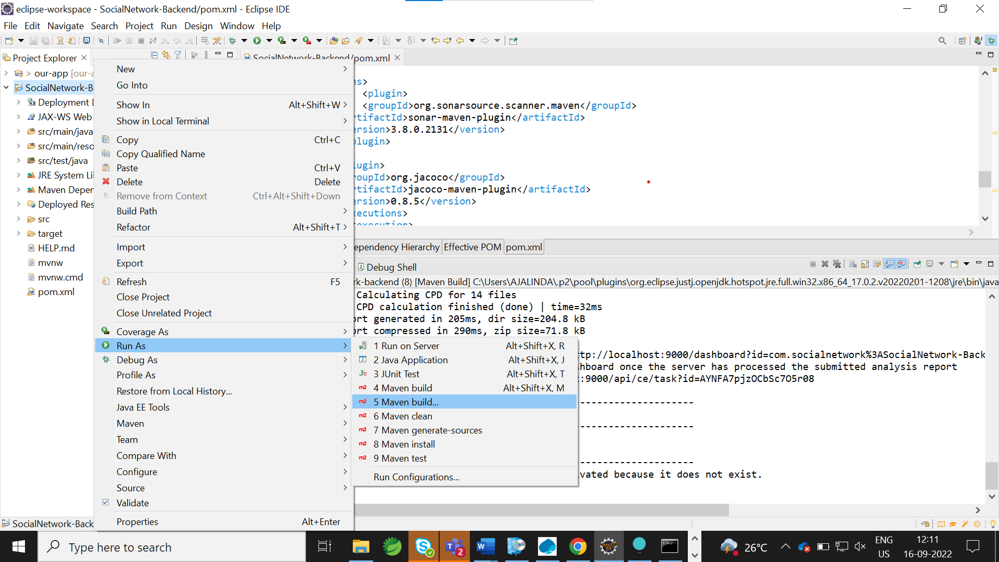

In goals text field copy paste the code like below shown format+generated token

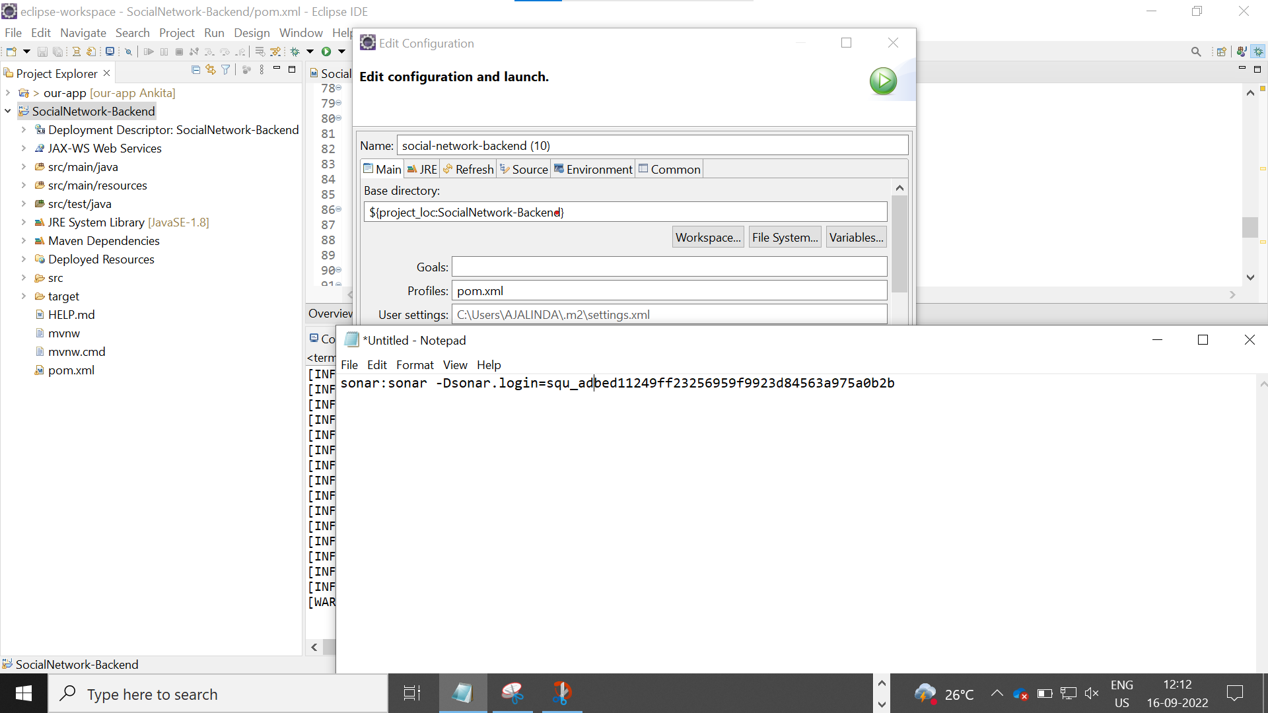

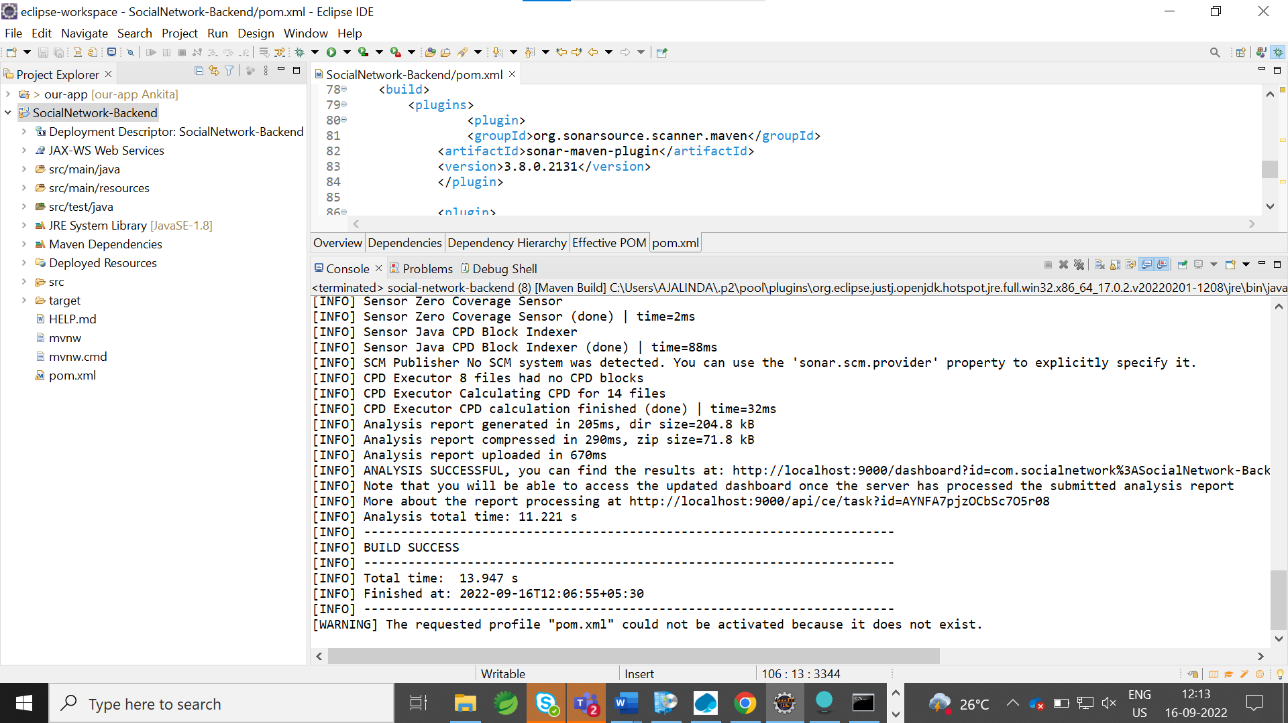

After build success open localhost:9000 in there check project

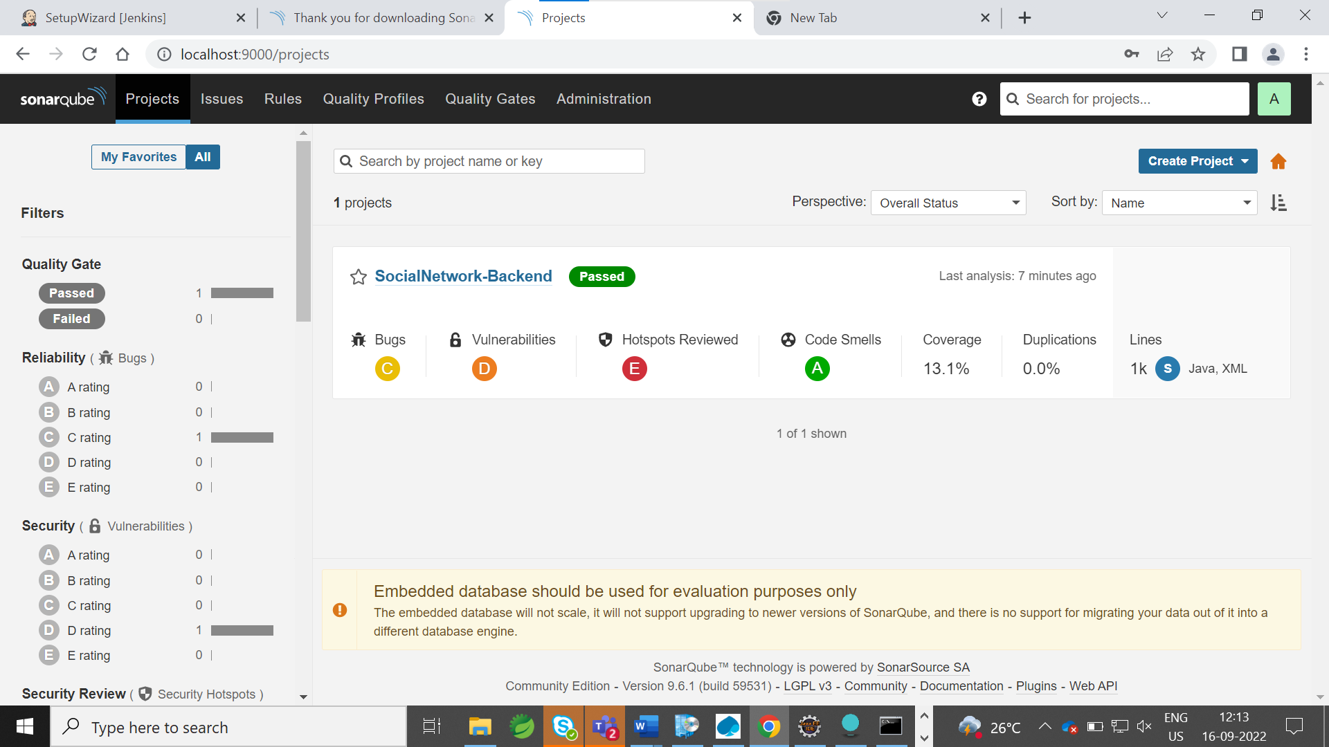

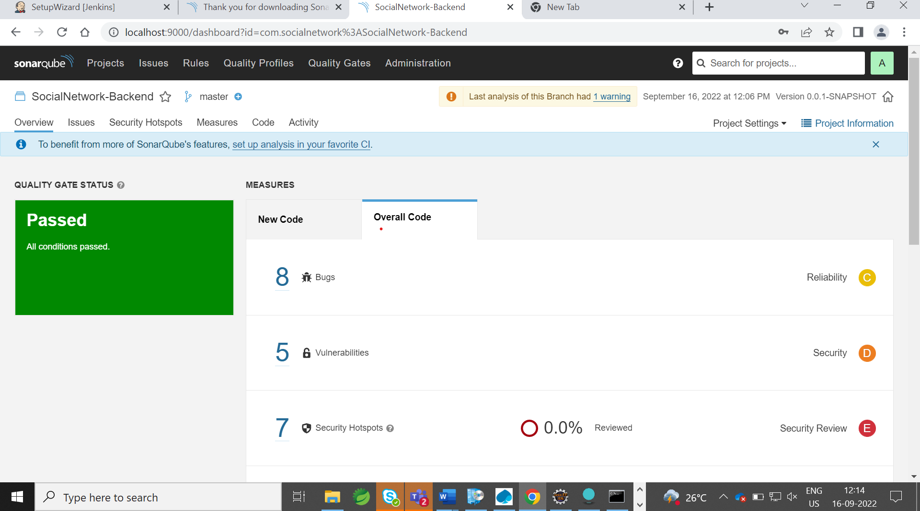

**Build passed…**